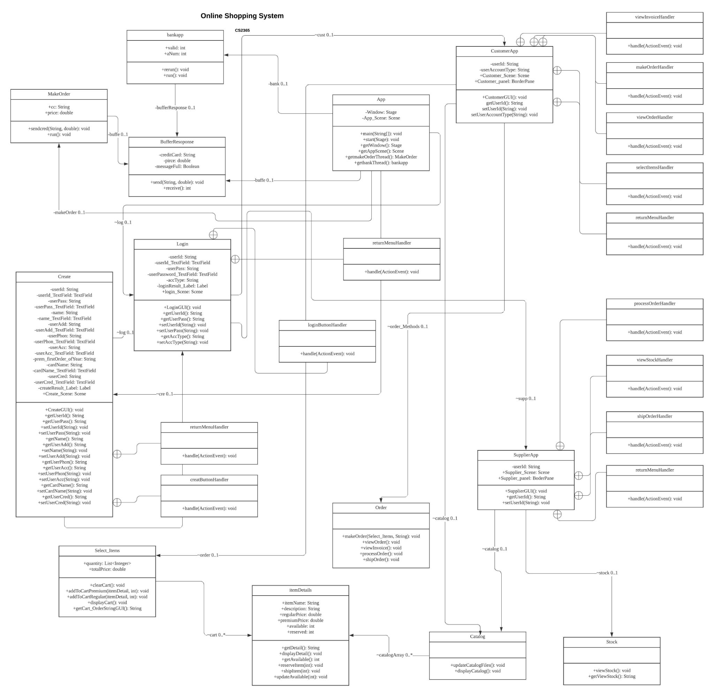**Assigned Text Files:**

Stock File - Stock.txt

Accounts - SavedAccounts.txt

Orders - Orders.txt

Bank - CreditCards.txt

Catalog - Catalog.txt

**Files containing the Message Buffer and Response Connector code:**

App.java - Has the threads start()

BufferResponse.java - code

BankApp.java - code

MakeOrder.java - code

CustomerApp.java - code